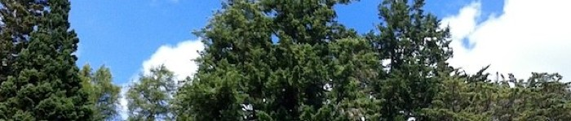

By completing this form, you are agreeing to the North East Forestry Group holding your details. Your details will not be passed on to any third party without your prior authorisation.

These details will be used, by us, for contacting you regarding your forest, and forwarding you information and event notices surrounding the forestry community.

If at any point you wish to be removed from the Group’s distribution list, please contact the Group Treasurer or Secretary and they will have your details removed.

North East Forestry Group Joining/Renewal Member’s Form

……………………………

Name:

Address:

……………………..

.........................................................

.........................................................

Mobile (or telephone):

.........................................................

E-mail:

.........................................................

Number of Hectares:

.........................................................

Species:

.........................................................

Year Planted:

.........................................................

----------------------------------------------------------------------------------------------

If your woodland is approaching first or subsequent thinning, please complete the following:

Hectares to be Thinned:

.........................................................

Species to be Thinned:

.........................................................

First or Second Thinning:

.........................................................

***Please use block capitals (if we cannot read your details, we cannot contact you).***